**Nginx Web Server**

In this documentation i will install Nginx web server and serve an html static page using it.

Install Nginx

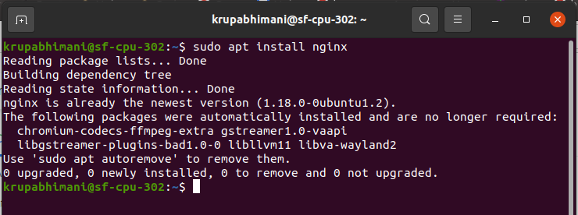

It is already installed so that the screen is like that

Start the server and check the status

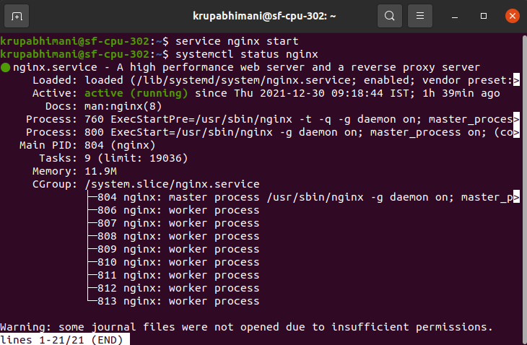

We can see it is running

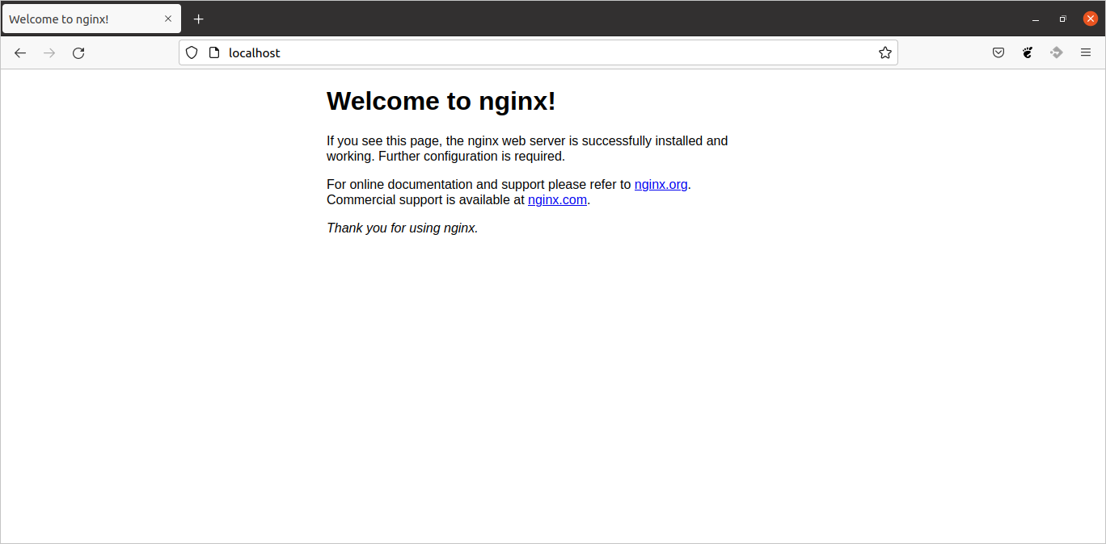

Visit the local host in the web browser and you will see this screen.

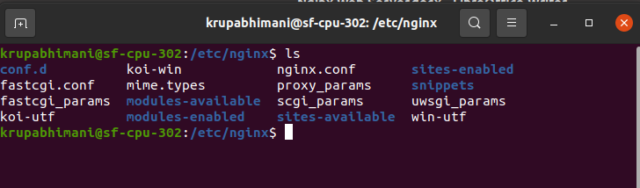

These are the all files and directories of nginx.

The main file for configuration is nginx.conf

* The default path for the html page in nginx is /var/www.

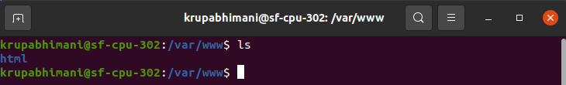

* Now to host our own website create on directory in www

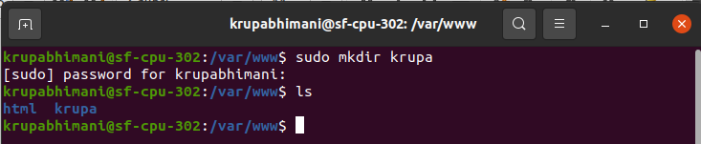

* create one html file in the folder

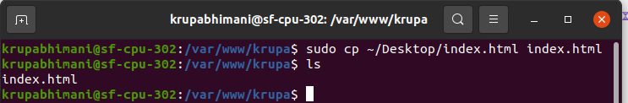

* The html page that is running on our localhost is set to default in **sites-available** directory. If we want to host our own website we can create its directory in sites-available directory and do its configuration in it.

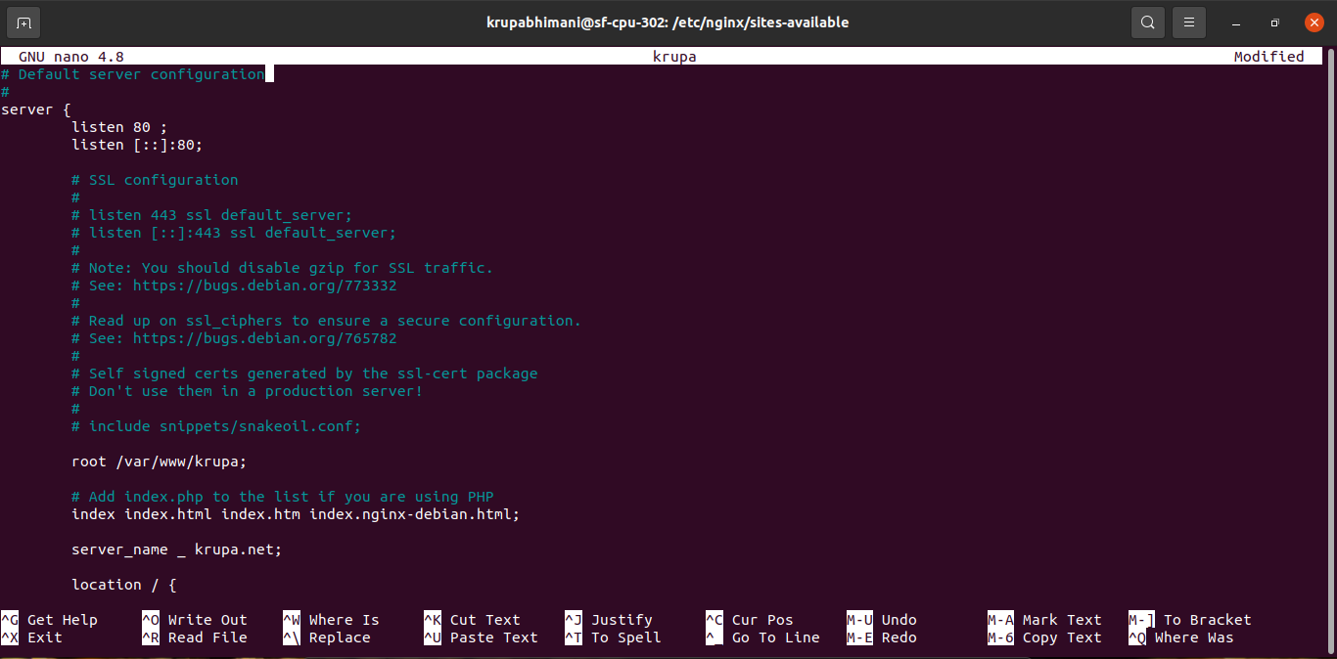

* Now create a soft link for this file between **sites-available** and **sites-enabled**

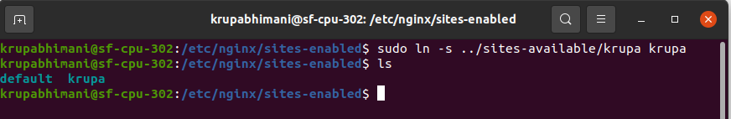

* Now we have configured everything, check the status of server

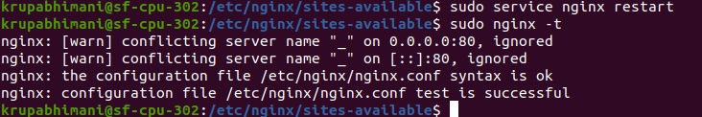

if want to try out your new virtual hosts without having to connect to an actual domain name, you can set up local hosts on your computer

Now we will do changes in /etc/hosts file

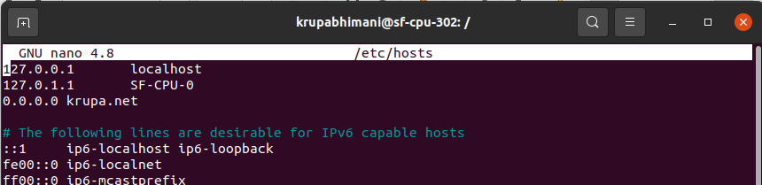

Now type krupa.net in the browser and you will see the website.

